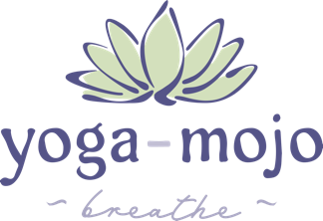
YOGA-MOJO
YOGA TEACHER TRAINING – RYT300/500
MODULE 3 – SPACE / ETHER / MIND
CONTENT OVERVIEW

HUMANITIES – YOGA PHILOSOPHY, LIFESTYLE & ETHICS
- Ethics and Equity
- Student Safety

TECHNIQUES, TRAINING & PRACTICE
- Asana Teaching Guide – Arm Balancing Poses
- Asana Teaching Guide – Inversion Poses
- Mantras Immersion ~
- Meditation Techniques Immersion
- Mudras Immersion
- Yoga-Mojo – The Magic of Mudra
- Sound Foundations Immersion
- Yoga Nidra Immersion

ANATOMY & PHYSIOLOGY
- Brain Health Neurological Conditions Immersion
- Brain Physiology Immersion
- Chronic Pain Immersion
- Digestive System Immersion
- Endocrine System Immersion
- Immune System Immersion
- Shoulder Girdle Immersion
- Subconscious and Shadow Work Immersion
- Upper Back, Neck and Shoulder Issues Immersion
- Flexibility and Stretching

TEACHING ESSENTIALS / TEACHING METHODOLOGY
- Teaching Beginners Immersion
- Intermediate – Advanced – Seniors Immersion
- Mental Health & Wellness Topics Immersion
- Strategic Planning Immersion
- Trauma and PTSD Immersion
- Business Planning / Crafting Workshops / Hosting Retreats
- Personal Practice and Self-Care
- Teaching Methodology – Sacred Space
- Your Presence as the Teacher

