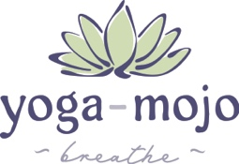
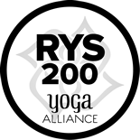
Yoga-Mojo Yoga Teacher Training
& Studies Program - YMYTT200

YMYTT - RYT200 Application

Thank you for your interest in Yoga-Mojo Yoga Teacher Training & Studies Program (YMYTT200). Before completing the application: If you haven’t taken a class with Loretta Jo, please take a class (outdoor/online) to ensure her style / method / communication works for you~ Attend a practice as a guest (no charge) or select a Yoga-Mojo Online Video on VIMEO and use promo code: YMGUEST at checkout. Loretta Jo is happy to address any questions you have about the practice of yoga and the YMYTT200 Program

Please complete this form and return to LJ@yoga-mojo.com or complete and send to Yoga-Mojo,
114 Ripplewater Lane, Cary, NC 27518

Name: __________________________________________________

Address: _________________________________________________

Phone: ___________________________

E-mail: ___________________________

Please complete the following:

1. Describe your yoga practice. Please include the following information:
- How long you’ve practiced
- Style of practice
- Studios you practice
- Teachers you’ve studied / practiced

__________________________________________________________________________________________
__________________________________________________________________________________________
__________________________________________________________________________________________
__________________________________________________________________________________________
__________________________________________________________________________________________
__________________________________________________________________________________________ __________________________________________________________________________________________
__________________________________________________________________________________________ __________________________________________________________________________________________ __________________________________________________________________________________________
- What brought you to yoga?

__________________________________________________________________________________________
__________________________________________________________________________________________
__________________________________________________________________________________________
__________________________________________________________________________________________

- Why did you choose Yoga-Mojo’s YTT?

__________________________________________________________________________________________
__________________________________________________________________________________________
__________________________________________________________________________________________
__________________________________________________________________________________________

- What are your goals for completing a Yoga Teacher Training?

__________________________________________________________________________________________
__________________________________________________________________________________________
__________________________________________________________________________________________
__________________________________________________________________________________________

- Do you have any concerns regarding the program?

__________________________________________________________________________________________
__________________________________________________________________________________________
__________________________________________________________________________________________
__________________________________________________________________________________________

- What are your hobbies / interests?

__________________________________________________________________________________________
__________________________________________________________________________________________ __________________________________________________________________________________________
__________________________________________________________________________________________

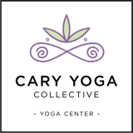
Thank you!
Upon receipt, your application will be reviewed, and you will be notified asap.

Yoga-Mojo recognizes the financial commitment to the YMYTT Program. Please advise of financial concerns or requesting considerations. Scholarships and Internships may be available and are considered on a case-by case basis. Upon acceptance, a formal agreement will be forwarded for your review and signature. This agreement will outline your commitment to the YMYTT both financially and physically.

